**Module 3 (Testing on Live Application)**

**Q-1 : What is RDBMS ?**

**Ans** : RDBMS stands for Relational Database Management System. RDBMS is the basis for SQL, and for all modern database systems like MS SQL Server, IBM DB2, Oracle, MySQL, and Microsoft Access.

**Q-2 : What is SQL?**

**Ans :**

* SQL stands for Structured Query Language
* SQL lets you access and manipulate databases
* SQL became a standard of the American National Standards Institute (ANSI) in 1986, and of the International Organization for Standardization (ISO) in 1987

**Q-3 : Write SQL Commands**

**Ans :** Sql commands are :

* DDL – Data Definition Language
* DML – Data Manipulation Language
* DCL – Data Control Language
* DQL – Data Query Language

**Q-4 : What is join?**

**Ans :** JOIN is used to combine the results of two tables. To perform a join, each of the tables must have at least one field which will be used to find matching records from the other table .The join type defines which records will go into the result set.

**Q-5 : Write type of joins.**

**Ans :**

1. INNER JOIN: returns rows when there is a match in both tables.

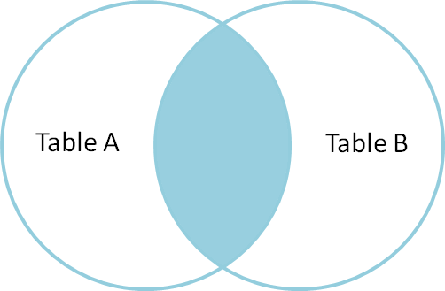

Structure: SELECT table1.column1,table1.column2,table2.column1,....

FROM table1

INNER JOIN table2

ON table1.matching_column = table2.matching_column;

e.g. SELECT StudentCourse.COURSE_ID,

Student.NAME, Student.AGE FROM Student

INNER JOIN StudentCourse

ON Student.ROLL_NO = StudentCourse.ROLL_NO;

1. LEFT JOIN: returns all rows from the left table, even if there are no matches in the right table.

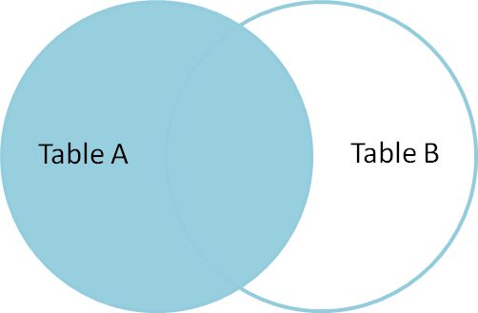

Structure: SELECT table1.column1,table1.column2,table2.column1,....

FROM table1

LEFT JOIN table2

ON table1.matching_column = table2.matching_column;

e.g. SELECT Student.NAME,StudentCourse.COURSE_ID

FROM Student

LEFT JOIN StudentCourse

ON StudentCourse.ROLL_NO = Student.ROLL_NO;

1. RIGHT JOIN: returns all rows from the right table, even if there are no matches in the left table.

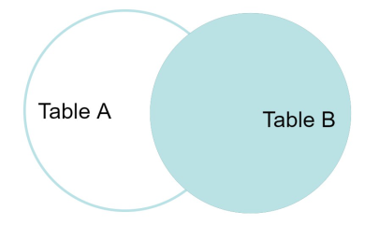

Structure: SELECT table1.column1,table1.column2,table2.column1,....

FROM table1

RIGHT JOIN table2

ON table1.matching_column = table2.matching_column;

e.g. SELECT Student.NAME,StudentCourse.COURSE_ID

FROM Student

RIGHT JOIN StudentCourse

ON StudentCourse.ROLL_NO = Student.ROLL_NO;

1. FULL JOIN: returns rows when there is a match in one of the tables.

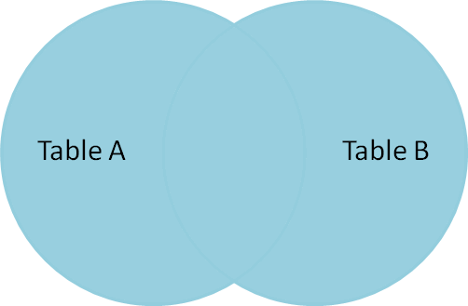

Structure: SELECT table1.column1,table1.column2,table2.column1,....

FROM table1

FULL JOIN table2

ON table1.matching_column = table2.matching_column;

e.g. SELECT Student.NAME,StudentCourse.COURSE_ID

FROM Student

FULL JOIN StudentCourse

ON StudentCourse.ROLL_NO = Student.ROLL_NO;

**Q-6 : How Many constraint and describes it self.**

**Ans :**

* NOT NULL - Ensures that a column cannot have a NULL value

e.g. CREATE TABLE CUSTOMERS (

ID INT NOT NULL,

NAME VARCHAR (20) NOT NULL,

AGE INT NOT NULL,

ADDRESS CHAR (25),

SALARY DECIMAL (18, 2)

);

* UNIQUE - Ensures that all values in a column are different

e.g. CREATE TABLE CUSTOMERS (

ID INT NOT NULL UNIQUE,

NAME VARCHAR (20) NOT NULL,

AGE INT NOT NULL,

ADDRESS CHAR (25),

SALARY DECIMAL (18, 2)

);

* PRIMARY KEY - A combination of a NOT NULL and UNIQUE. Uniquely identifies each row in a table

e.g. CREATE TABLE CUSTOMERS(

ID INT NOT NULL,

NAME VARCHAR (20) NOT NULL,

AGE INT NOT NULL,

ADDRESS CHAR (25),

SALARY DECIMAL (18, 2),

PRIMARY KEY (ID)

);

* FOREIGN KEY - Prevents actions that would destroy links between tables

e.g. CREATE TABLE ORDERS (

ID INT NOT NULL,

DATE DATETIME,

CUSTOMER_ID INT FOREIGN KEY REFERENCES CUSTOMERS(ID),

AMOUNT DECIMAL,

PRIMARY KEY (ID)

);

* CHECK - Ensures that the values in a column satisfies a specific condition

e.g. CREATE TABLE CUSTOMERS(

ID INT NOT NULL,

NAME VARCHAR (20) NOT NULL,

AGE INT NOT NULL CHECK(AGE>=18),

ADDRESS CHAR (25),

SALARY DECIMAL (18, 2),

PRIMARY KEY (ID)

);

* DEFAULT - Sets a default value for a column if no value is specified

e.g. CREATE TABLE CUSTOMERS (

ID INT NOT NULL UNIQUE,

NAME VARCHAR (20) DEFAULT 'Not Available',

AGE INT NOT NULL,

ADDRESS CHAR (25),

SALARY DECIMAL (18, 2)

);

* CREATE INDEX - Used to create and retrieve data from the database very quickly

e.g. CREATE INDEX idx_age ON CUSTOMERS ( AGE );

**Q-7 : Difference between RDBMS vs DBMS**

**Ans :**

|  |  |
| --- | --- |
| **DBMS** | **RDBMS** |
| [DBMS](https://www.geeksforgeeks.org/introduction-of-dbms-database-management-system-set-1/) stores data as file. | [RDBMS](https://www.geeksforgeeks.org/rdbms-architecture/) stores data in tabular form. |
| Data elements need to access individually. | Multiple data elements can be accessed at the same time. |
| No relationship between data. | Data is stored in the form of tables which are related to each other. |
| Normalization is not present. | Normalization is present. |
| DBMS does not support distributed database. | RDBMS supports distributed database. |
| It stores data in either a navigational or hierarchical form. | It uses a tabular structure where the headers are the column names, and the rows contain corresponding values. |
| It deals with small quantity of data. | It deals with large amount of data. |
| Data redundancy is common in this model. | Keys and indexes do not allow Data redundancy. |
| It is used for small organization and deal with small data. | It is used to handle large amount of data. |
| Not all Codd rules are satisfied. | All 12 Codd rules are satisfied. |
| Security is less | More security measures provided. |
| It supports single user. | It supports multiple users. |
| Data fetching is slower for the large amount of data. | Data fetching is fast because of relational approach. |
| The data in a DBMS is subject to low security levels with regards to data manipulation. | There exists multiple levels of data security in a RDBMS. |
| Low software and hardware necessities. | Higher software and hardware necessities. |
| Examples:[XML](https://www.geeksforgeeks.org/xml-basics/), Window Registry, Forxpro, dbaseIIIplus etc. | Examples: [MySQL](https://www.geeksforgeeks.org/architecture-of-mysql/), [PostgreSQL](https://www.geeksforgeeks.org/what-is-postgresql-introduction/), [SQL](https://www.geeksforgeeks.org/what-is-sql/) Server, Oracle, Microsoft Access etc. |

**Q-8 : What is API Testing**

**Ans :**

Application Programming Interface (API) is a software interface that allows two applications to interact with each other without any user intervention

* another definition , API (Application Programming Interface) is a computing interface which enables communication and data exchange between two separate software systems.
* The purpose of API Testing is to check the functionality, reliability, performance, and security of the programming interfaces.
* In API Testing, instead of using standard user inputs(keyboard) and outputs, you use software to send calls to the API, get output, and note down the system’s response.
* API tests are very different from GUI Tests and won’t concentrate on the look and feel of an application.

**Q-9 : Types of API Testing**

**Ans:** There are mainly 3 types of API Testing

1. **Open APIs:** These types of APIs are publicly available to use like OAuth APIs from Google. It has also not given any restriction to use them. So, they are also known as Public APIs.
2. **Partner APIs:** Specific rights or licenses to access this type of API because they are not available to the public.
3. **Internal APIs**: Internal or private. These APIs are developed by companies to use in their internal systems. It helps you to enhance the productivity of your teams.

**Q-10 : What is Responsive Testing?**

**Ans** : A responsive web design involves creating a flexible web page that is accessible from any device, starting from a mobile phone to a tablet.

* Furthermore, a responsive web design improves users’ browsing experience. Considering this from a quality assurance perspective, a responsive web design requires thorough evaluation using a variety of devices before it is ready to go live.
* Software testers may find it challenging to perform responsive design testing as a variety of factors are to be looked into during the testing phase.
* Some points to be understand for Responsive Testing.
  + The challenges involved in testing a responsive
  + website How website testing differs from a mobile device to a computer
  + Rules and guidelines to be followed during responsive design testing and
  + Lastly, various tools available to perform responsive testing

**Q-11 : Which types of tools are available for Responsive Testing**

**Ans** : Here are the tools for responsive testing,

* LT Browser
* Lembda Testing
* Google Resizer
* I am responsive
* **Pixel tuner**

**Q-12 : What is the full form of .ipa, .apk**

**Ans :** .ipa : iOS package App Store.

.apk : Android Package.

**Q-13 : How to create step for to open the developer option mode ON?**

**Ans :**

**Step 1:** Go to Settings > About phone.

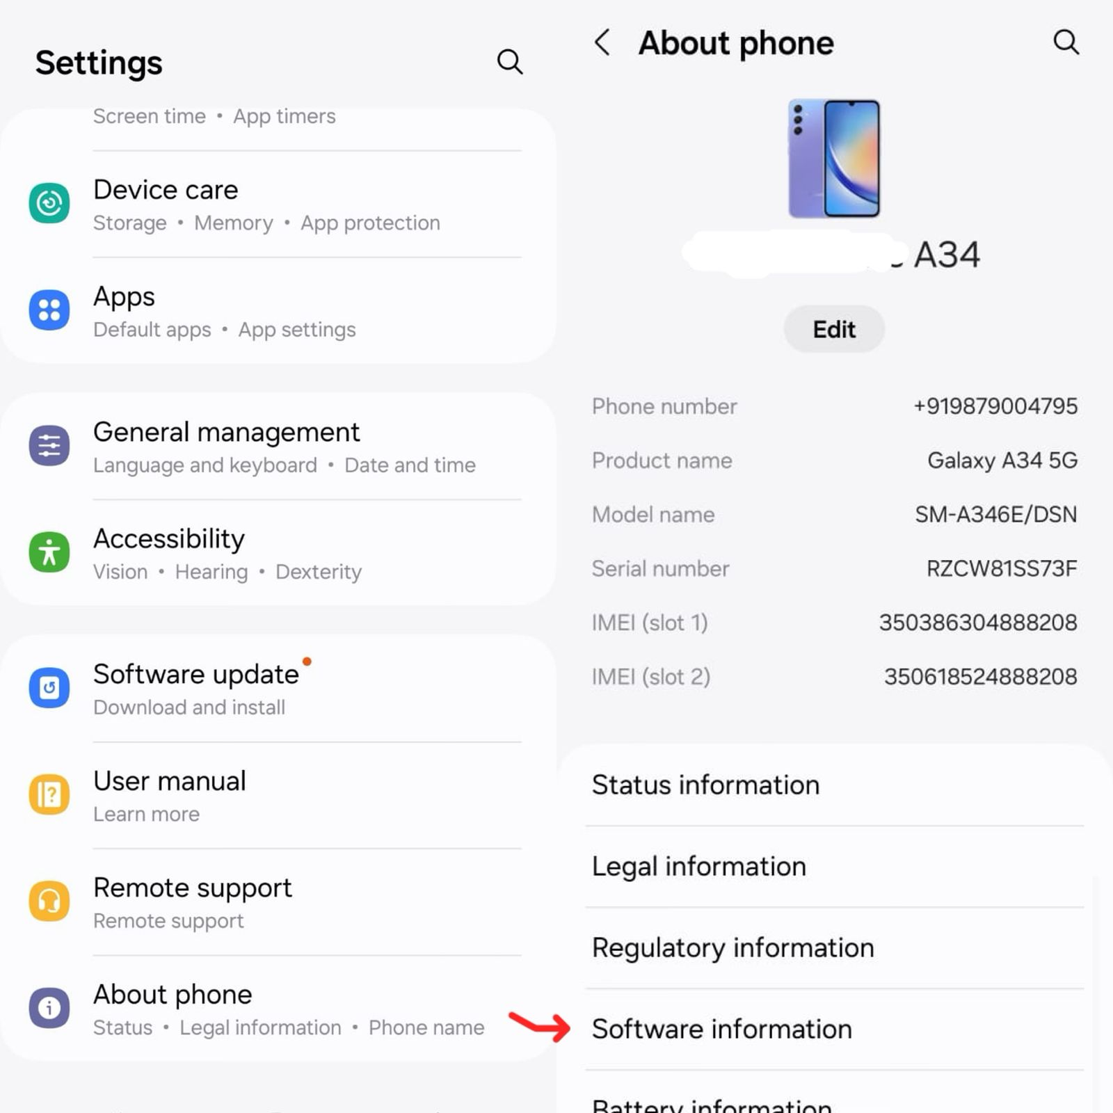

**Step 2:** Scroll down to Build number.

**Step 3:** Tap Build number seven times. After the first few taps, you should see the steps counting down until you unlock the developer options. You may also have to tap in your PIN for verification.

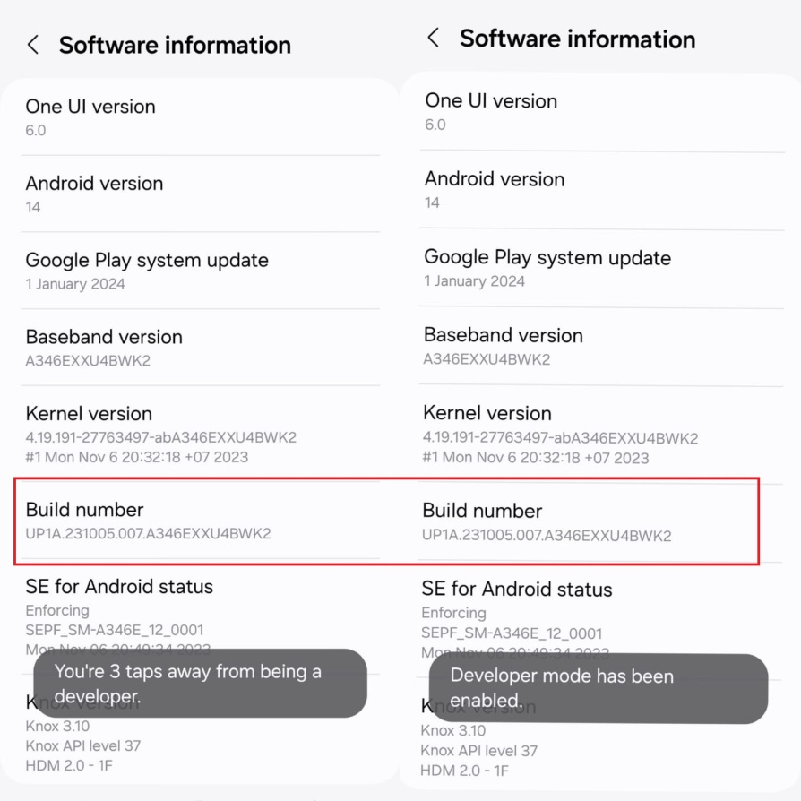

**Step 4:** Once developer options are activated, you will see a message that reads, You are now a developer.

**Step 5:** Go back to the Settings pane and head to System, where you will now find Developer options as an entry.

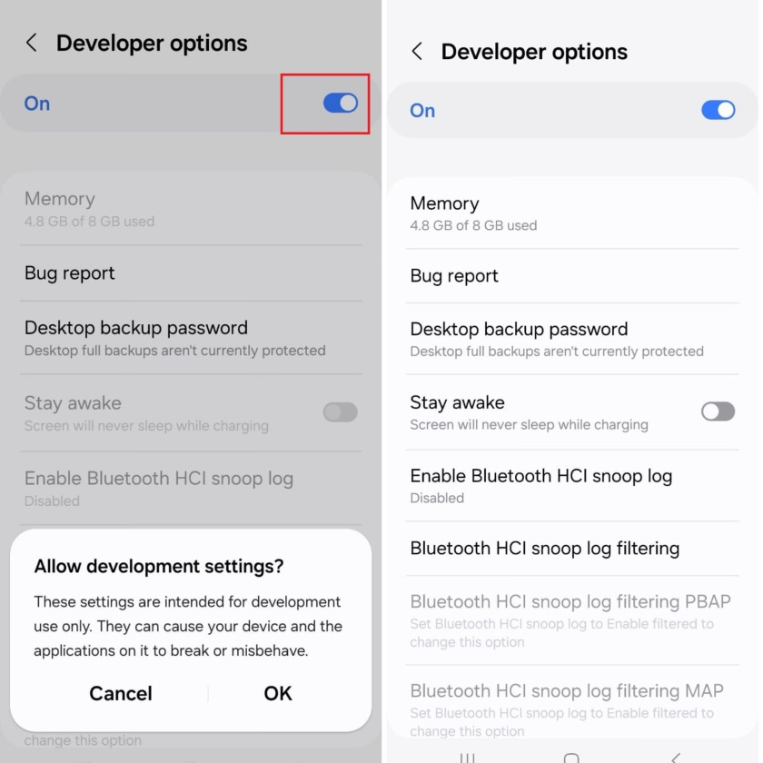

**Step 6:** Tap it and toggle the switch on if it is not already, and from there, you can proceed to make adjustments to your phone.and on/off usb debugging option for testing APIs

